THE MILWAUKEE CHAPTER – Come write your book with us! PASTOR TERESA THOMAS-BOYD, PRESIDENT – 414-507-1115 AND MINISTER WENDELL HARRIS, VICE PRESIDENT – 414-915-5297 along with Apostle Wendale Spivery, Jesus International and Pastor Patrick Keen, Our Savior’s Lutheran Church
PRESENTS

“A MORAL REVIVAL WITH DR. WILLIAM BARBER II”
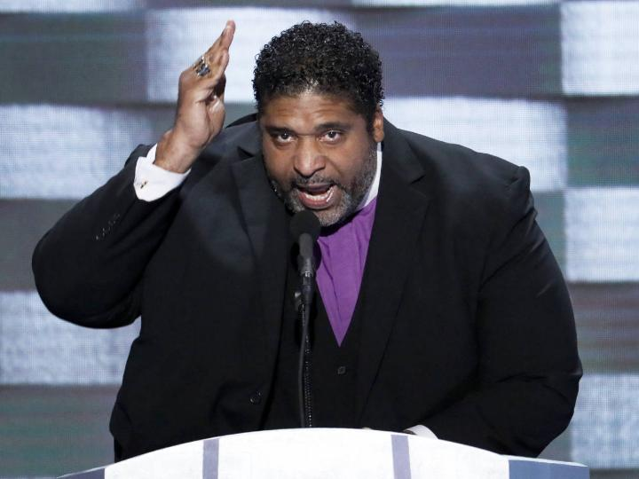
WEDNESDAY, NOVEMBER 2, 2016
MPOLIS – Moral Political Organizing Leadership Institute and Summit
9:00 a.m. – 2:00 p.m.
Host: Pastor Walter Lanier, Progressive Missionary Baptist Church 8324 W. Keefe Avenue, Milwaukee, WI Limited Space -REGISTRATION REQUIRED: Contact Montre Moore, 414-639-0000
A MORAL REVIVAL – 7:00 p.m. – 9:00 p.m.
Host: Pastor Patrick Keen, Our Savior’s Lutheran Church 3022 W. Wisconsin Avenue (Entrance and Parking off Wells) Limited Space – TICKETS REQUIRED: Pastor Boyd, 414-507-1115
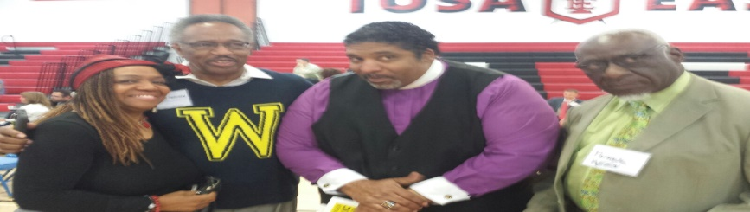
“A Milwaukee Moral Revival Summary”
The Milwaukee Chapter of SPAA (Speakers Publishers Authors and Association) – an premiere international non-profit membership organization founded in 2007, is dedicated to providing ongoing training and development in professional speaking, writing and publishing opportunities along with Jesus International Ministries and Our Savior’s Lutheran Church is enthused to present “A Moral Revival” with Dr. William Barber II, NAACP State President North Carolina (largest in the Southern States and 2nd largest in the country) and Pastor of Greenleaf Christian Church, Disciples of Christ to Milwaukee, WI on Wednesday, November 2, 2016.
The itinerary includes a Moral Political Organizing Leadership Institute and Summit (MPOLIS) Wednesday, 9:00 a.m. – 2:00 p.m., hosted by Pastor Walter Lanier, Progressive Baptist Church, 8324 W. Keefe Avenue. The institute and summit is a workshop, training and gathering of clergy and lay leaders from all faith traditions to engage in discussion on the moral imperative in social justice work and community involvement. The goal of the MPOLIS is to provide an additional resource to social justice work in states and communities across the country. PREREGISTRATION REQUIRED – LIMITED SPACE - Contact Mr. Montre Moore, 414-639-0000 Some topics will include:
- Sacred Songs and Culture in Social Justice Movements
- Biblical Foundations/Exegesis (old testament and new testament)
- History of the Moral Prophetic Voice
- A Critique and History of the So-Called Religious Right
- Organizing and Shaping a Moral Vision for Justice in the Public Square
- Discussion of Issues Relative to Milwaukee and Wisconsin
Wednesday evening the “Moral Revival”, 7:00 p.m. – 9:00 p.m., hosted by Pastor Patrick Keen, Our Savior’s Lutheran Church, 3022 W. Wisconsin Avenue (use back entrance off Wells Street). TICKETS ARE REQUIRED – LIMITED SEATING – Contact Pastor Teresa Thomas-Boyd, 414-507- 1115. Dr. William Barber II will speak to the moral revolution of values, local leaders telling their stories about issues impacting their lives, and interfaith leaders throughout the state joining together to lift up and defend the most sacred moral principles of our faith and constitutional values, which are:
- Pro-labor and anti-poverty policies
- Equality in education for every child
- Healthcare for all
- Fairness in the criminal justice system
- Fundamental human rights for all

